**Experiment 2.3**

**Name :- Yash Gupta Uid :- 20BCS5009**

**Course :- CSE Section :- 709-A**

**Subject :- Programming in Python Subject Code :- 20CSP-259**

# **Aim :-**

1. **Write a Python program to combine two dictionary adding values for common keys. d1 = {'a': 100, 'b': 200, 'c':300},d2 = {'a': 300, 'b': 200, 'd':400}**

**Code:-**

**from collections import Counter**

**d1 = {'a': 100, 'b': 200, 'c':300}**

**d2 = {'a': 300, 'b': 200, 'd':400}**

**d1 = Counter(d1) + Counter(d2)**

**print(d1)**

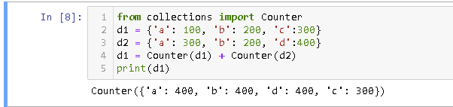

1. **Write a Python program to find the highest 3 values of corresponding keys in a dictionary.**

**Code:-**

**from collections import Counter**

**my_dict = {'t': 3, 'u': 4, 't': 6, 'o': 5, 'r': 21}**

**k = Counter(my_dict)**

**high = k.most_common(3)**

**print("Dictionary with 3 highest values:")**

**print("Keys: Values")**

**for i in high:**

**print(i[0],":",i[1])**

